**Content**

**1. About this Document ……………………………….................... 2**

**1.1 How this Document is organized ……………………………….. 2**

**1.2 Contact Information ..……………………………………………..…. 3**

**2. Introduction ……………………………………………………………..... 4**

**2.1 Objectives …………………………………………………….……........ 4**

**3. Flow chart ……………………………….................................... 5**

**3.1 Flow chart diagram …….…………………………………..…………… 5**

**4. Sprints ………………………………………………………………..…… 6**

**5. Solution Overview …………………………………………………….. 8**

**5.1 User Interfaces ……………………………………………………….… 8**

**6. Github ……………………………………………………………………….. 9**

**1. About this Document**

This functional and integration (FIS) document will enable you to understand the proposed solution of Flyaway.com

The content of the document will have a solution and its configuration details as it will be available for our client.

**1.1 How this Document is organized**

This document is organized into following chapters:

Chapter 2 - "Introduction" provides solution scope to be delivered to our Client.

Chapter 3 - "Flow chart" provides how the user is interacting with the application.

Chapter 4 - "Sprint Planning" provides how the application was developed in each sprint.

Chapter 5 - "Solution Overview" provides information on Company Lockers Pvt. Ltd.

Components and Interfaces in system.

Chapter 6 - “Open Items” provide information about the software enhancement

still to be done.

Chapter 7- “Github link” provides the information where the project is located.

**1.2 Contact Information**

Flyaway welcomes your comments and suggestions on the quality and usefulness of this document. For any questions, comments, or suggestions on the documentation, you can contact us at the following address:

**For Contact and enquiry**

Gautam Das

Tel: +91 7980876391

**2. Introduction**

This document describes the implementation of Flyaway and how its users can interact with the application.

FlyAway is a ticket-booking portal that lets people book flights on their website.

**2.1 Objectives**

The objective of this document is to describe how the solution of Flyaway will integrate with User.

This document also provides information on end to end workflow so that business users can understand the features and functionalities of the Flyaway an online booking portal.

The workflow mainly involves the following important aspects,

1. A search form in the homepage that allows user to enter travel details like the date of travel, source, destination and the number of persons.

2. Based on the travel details entered, it will show the available flights with their ticket prices.

3. Once a person selects a flight to book, they will be taken to a login page where they must fill in their user details.

4. If he/she is not a user they will be taken to the registration page.

5. In the next page, they are shown the flight details of the flight that they have booked and the payment is done via a dummy payment gateway.

6. On completion of the payment, they are shown a confirmation page with the details of the flight they have booked.

**3. Flow chart**

3.1. The objective of this session if to show how the user interacts with the flow of the Company Lockers Pvt. Ltd.

**Start**

User is asked to enter Origin and destination for searching available flgetkmspico.comights

Based on user provided details the available flights are shown to user to book

Register

User books a flight

No

Already Registered?

Login

Yes

Dummy Payment Gateway

Confirmed Booking Details

**Stop**

**4. Duration of Sprints required:**

* I have divided this application in 2 sprints of 7 days each. In first 2 days I made a plan to how to create the application, the next 4 days I developed the application code for Home page and creation of database in workbench and created Register and login and the last day of the first sprint I tested the Application.

In the second sprint I developed code for Booking page , searching for flights, Search for Places and Payment page . Then I tested the whole application. Afterwards I prepared the documentation and flow chart

**5. Solution Overview**

Platform requirement

The platform used for this project is the eclipse IDE, Tomcat, MySQL workbench

Below is the Home page of the application

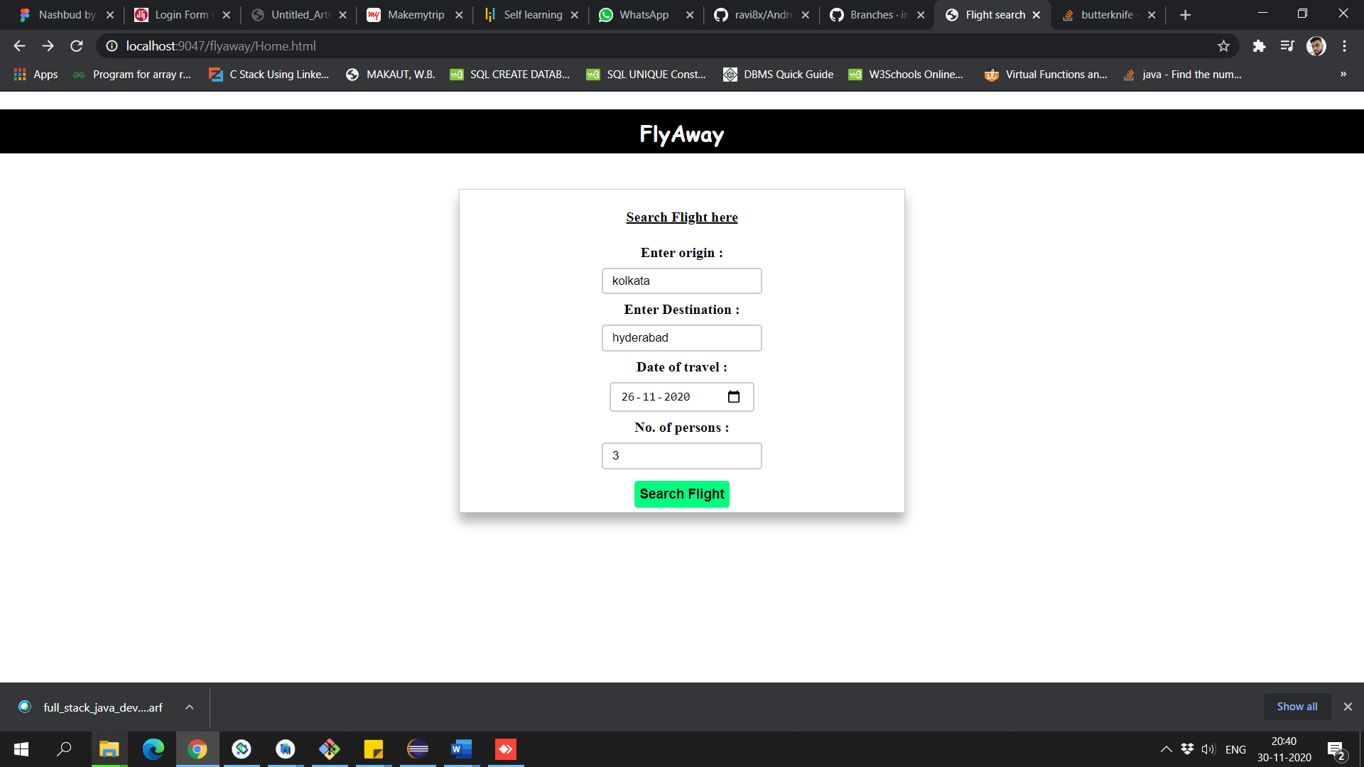

Below is the Available flights for the destination

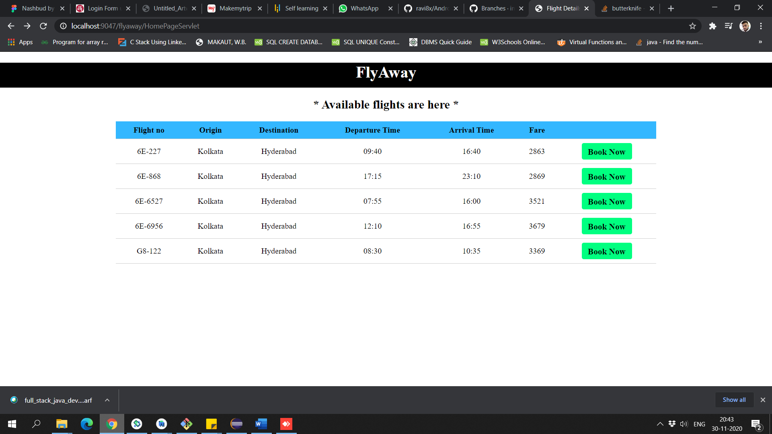

Below is the Login/Register for the user

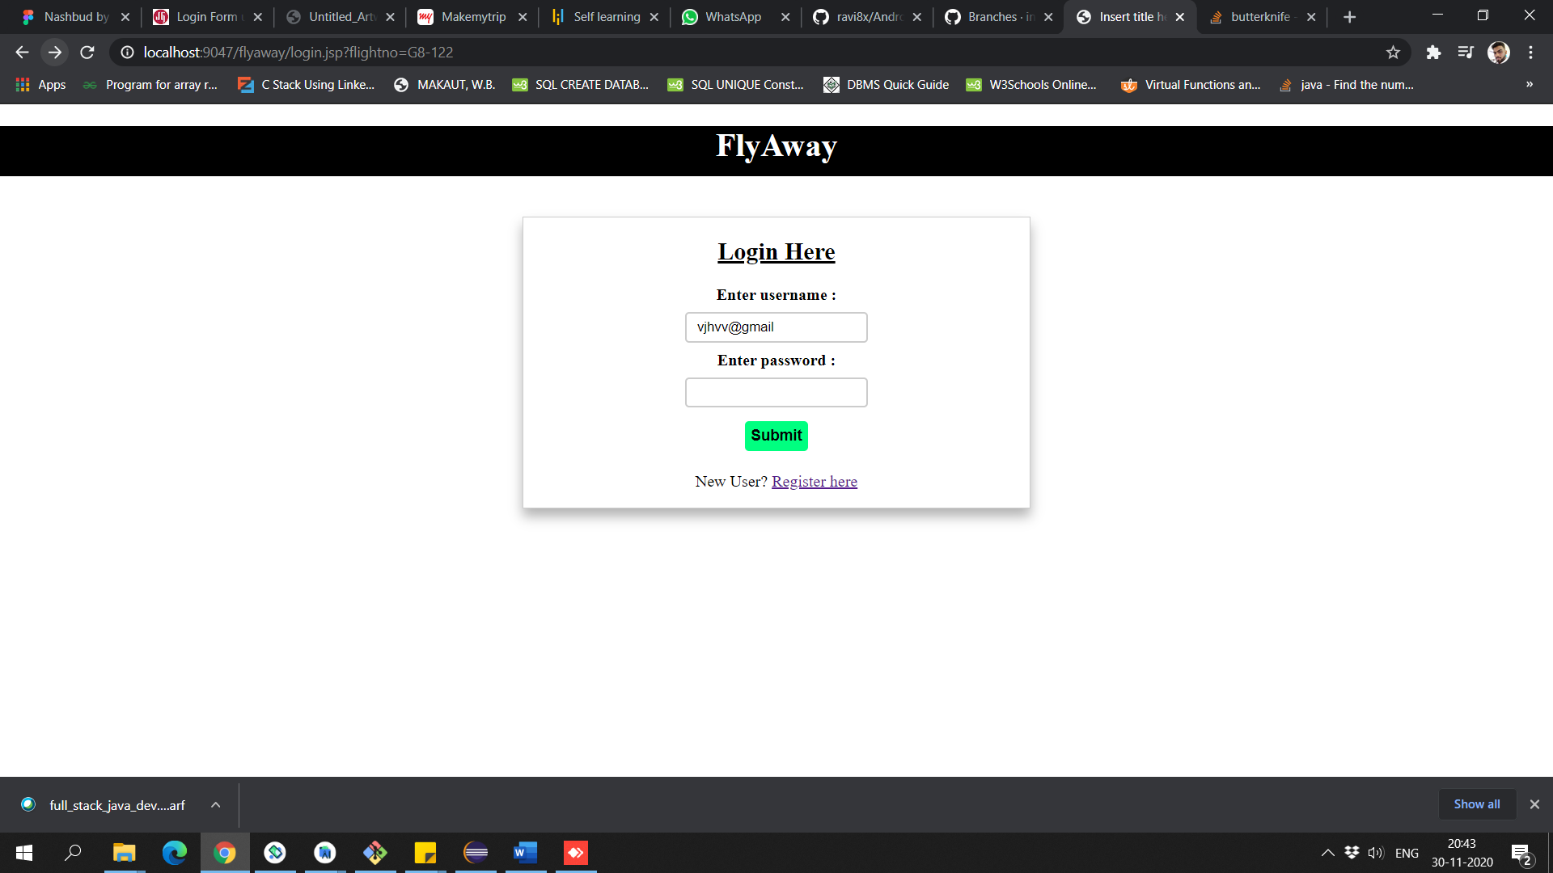

Below is the Payment Page for the user

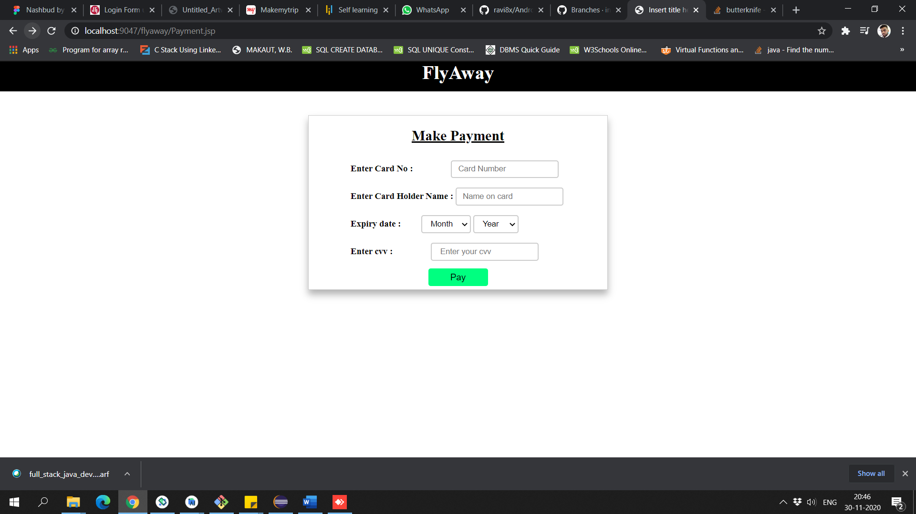

Below is the Booking Page

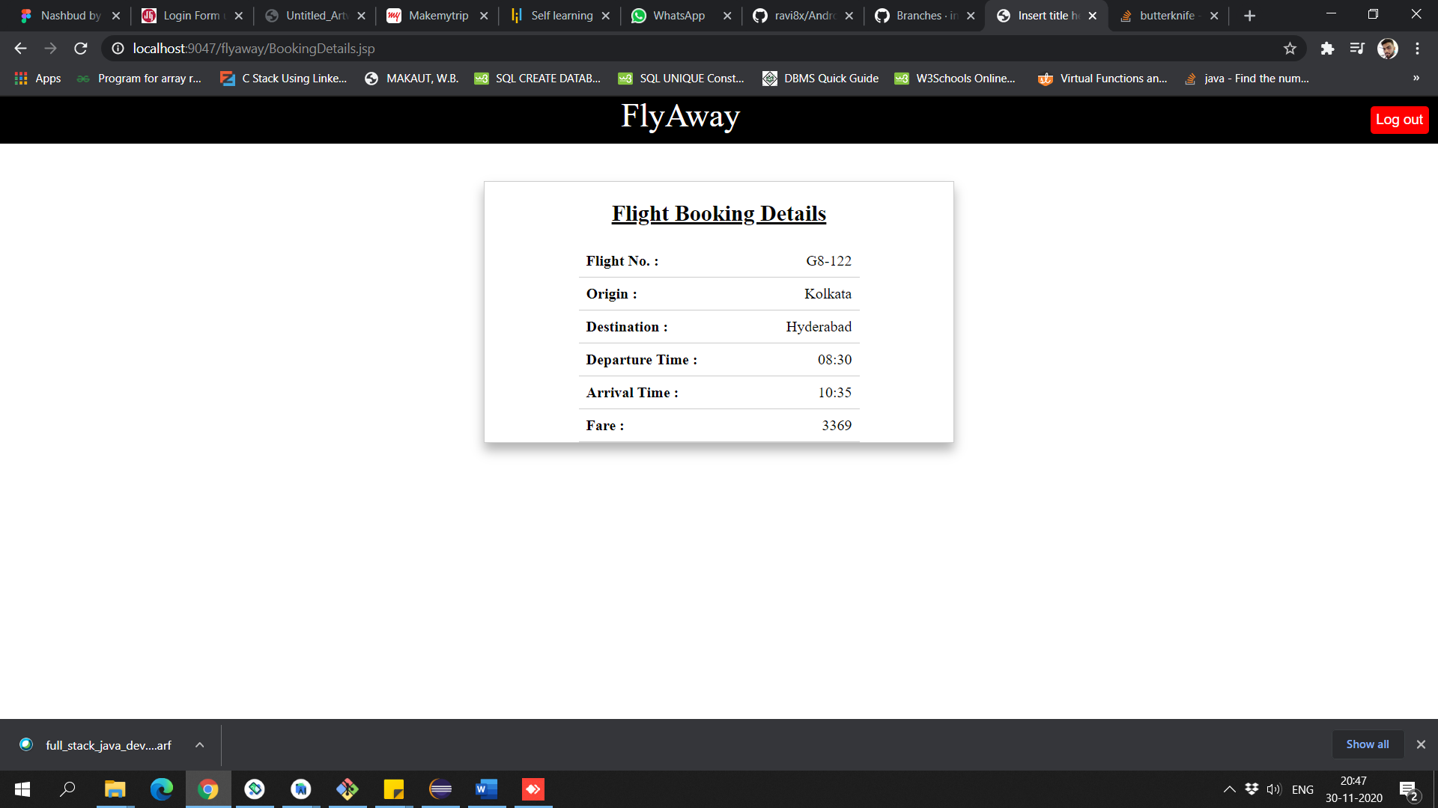

**Database:-**

In order to store the data of the flights and users there is a master database.

There are 3 tables to store the data

1. Flightdetails – all the flights details are stored in this table.
2. Userdetails – all the users details are stored in this table.
3. Admindetails – all the admin details are stored in this table.

Table 1:

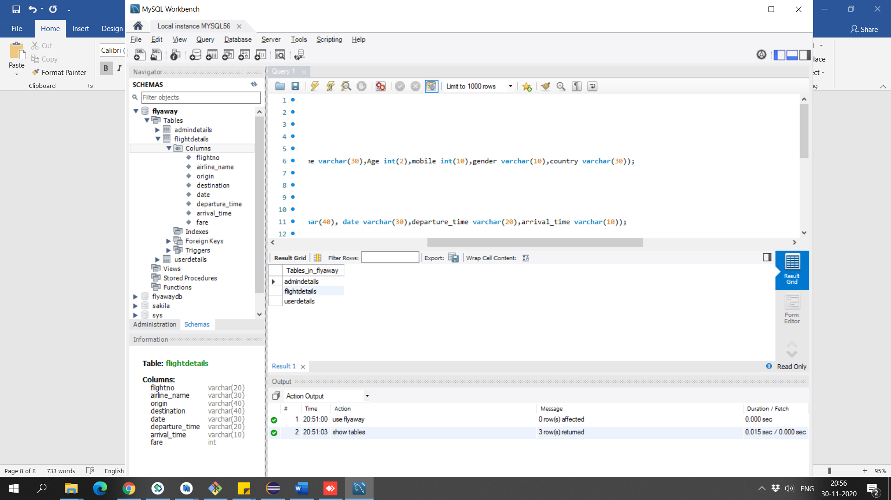

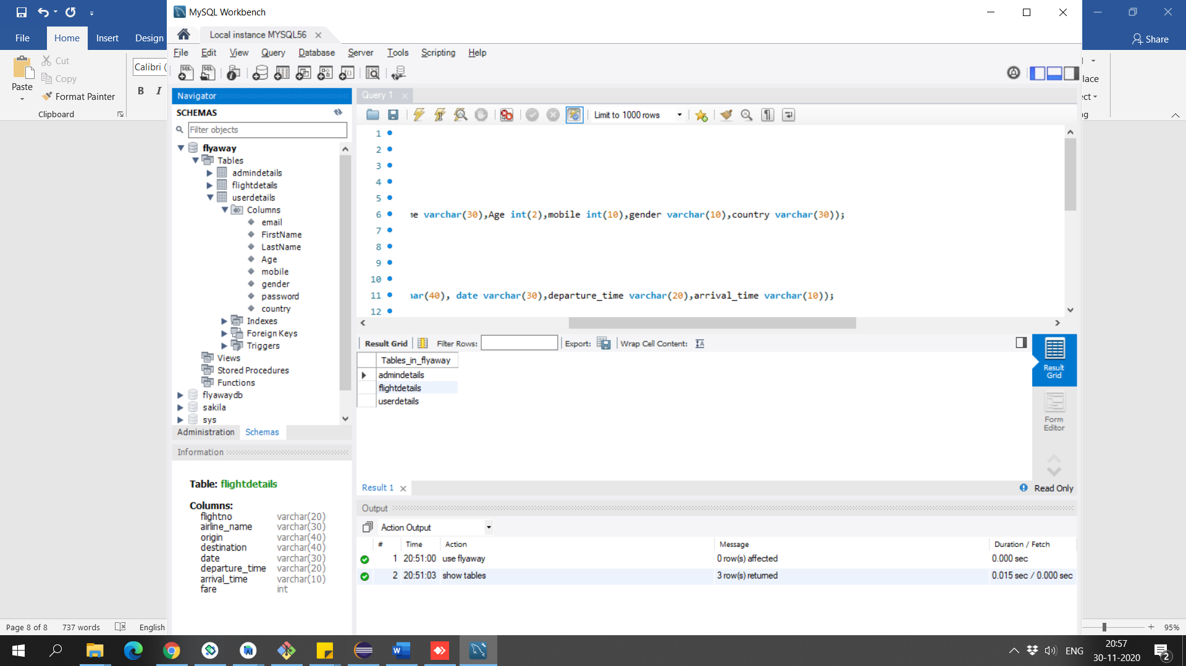Table 2:

Table 3:

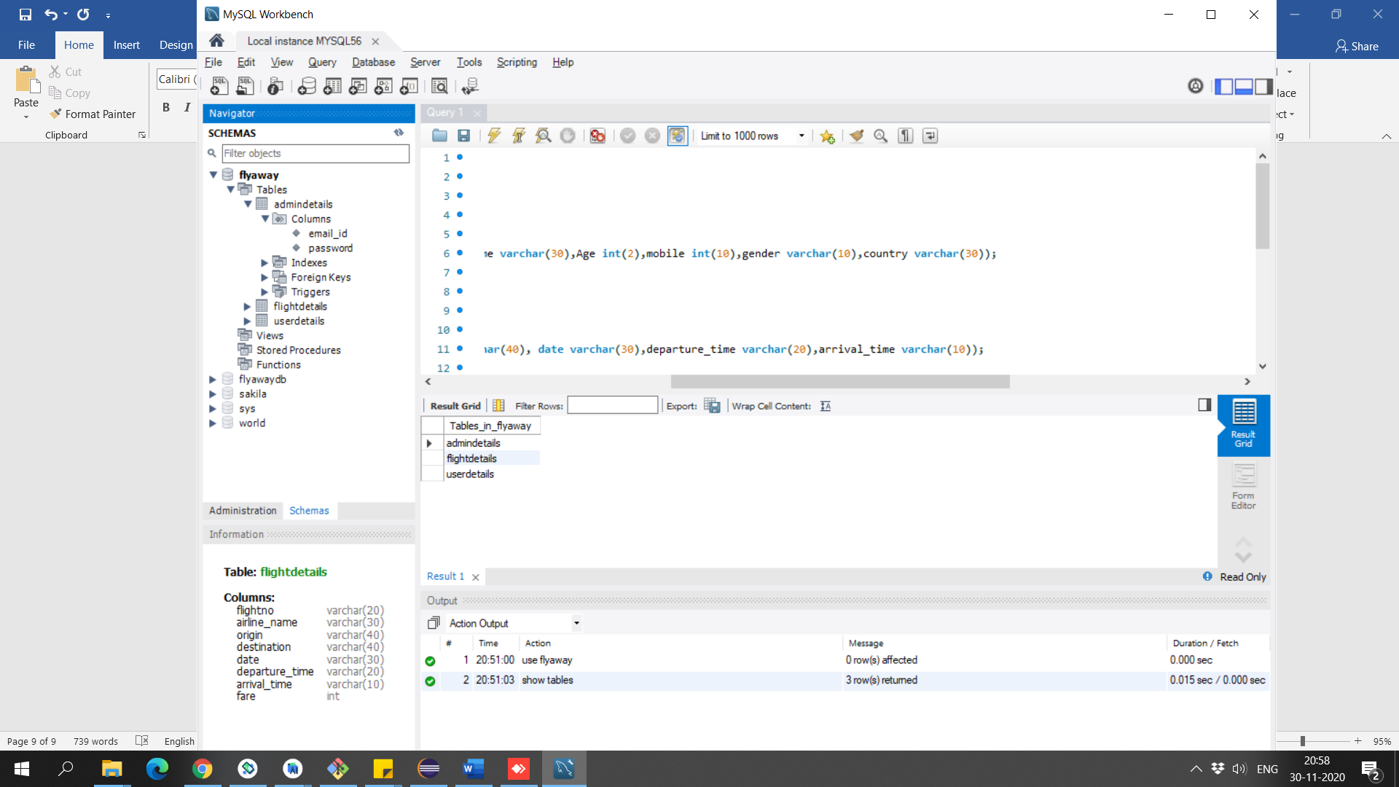

**6. Github Link**

[**https://github.com/codergautam25/Phase2-Flyway.git**](https://github.com/codergautam25/Phase2-Flyway.git)